INFLUENCE OF DISASTER KNOWLEDGE RELATIONSHIP
AND ENVIRONMENTAL LEADERSHIP IN OVERCOMING FLOOD
WITH FLOOD DISASTER PREPARED BEHAVIOR

Sarah Agustina Rumawak1 and Yossa Istiadi2
1Postgraduate Student, Environmental Management Study Program, Pakuan University
Jl. Pakuan Bogor Post Box. 452 Bogor
Email: alenbiakbiak@gmail.com
2 Graduate School of Environmental Management Study Program Pakuan University
Jl. Pakuan Bogor Post Box. 452 Bogor
Email: yossaistiadi@unpak.ac.id

ABSTRACT

The objective of this study is to describe and analyze the relationship between disaster knowledge and environmental leadership in dealing with floods with flood disaster preparedness behavior in Abepura sub-district. The population of this research is the head of household in Abepura District, Abepura District with a total of 10,688 people. The sample was taken using a multistage proportional random sampling technique, namely choosing a village that was used as the sampling area and then choosing an area that was very prone to flooding so that the Awio Village was selected with a sample of 30 respondents. The questionnaire consists of 3 (three) instruments, namely the flood preparedness behavior instrument (30 questions), the disaster knowledge instrument (26 questions) and the leadership instrument (29 questions). Rating scale with five answer choices that have the lowest value of 1 and the highest value of 5, namely for positive statements and for negative statements otherwise. The results showed the relationship between knowledge and leadership simultaneously (F=280,802,sig=0,000, p<0,05). The partial relationship of disaster knowledge contributes individually and significantly to disaster preparedness behavior (ꞵ=0.097, sig=0.028, p<0.05) and leadership also contributes individually and significantly to disaster preparedness behavior (ꞵ=0.954, sig=0.000, p<0.05). The results showed that the level of community knowledge was still low, because they did not know about the causes of the flood disaster (60% of respondents), the level of leadership was still low, it was seen that disaster preparation planning had never been carried out (50% of respondents), and the behavioral dimension was still relatively low with the percentage behavior does not care about the preservation of nature (40% of respondents). The study recommends collective leadership so that each individual will complement each other according to their strengths, so that it will increase the effectiveness of each phase of disaster management that has been planned.

Keywords: flood disaster, knowledge, environmental leadership, alert behavior

I. INTRODUCTION
Data (BNPB, 2020) of disaster events in Indonesia for the last few years (2016 to 2020), the number has increased. For example, since 2016 there have been 2308 incidents, in 2017 there were 2869 incidents, in 2018 there were 2573 incidents, in 2019 there were 1037 incidents and in 2020 there were still 1 incident. Likewise, victims of disasters to humans, the value of damage and losses in several sectors has increased from the data, seen from the graph of an increase in disasters that occur in Indonesia every year.
Data (BNPB, 2019) noted that Abepura District is a flood-prone area and caused several losses and even casualties. From 2015 to 2019 the number of flood disasters was 10 and 983 people were injured, 4,330 people evacuated, some damage due to flooding occurred, 737 heavily damaged, 9 moderate damaged, 400 lightly damaged, flooded 2,846, health facilities 3 , engagement facilities 19 educational facilities 21, public facilities 15, damaged bridges 7, damaged factories 1, food stalls/stalls 108. Some data on flood victims at locations or in Abepura District, Jayapura City, Papua Province.
This change has an impact on the development of disaster management in Indonesia. One of the right steps to reduce disaster risk is to carry out mitigation efforts, both structural mitigation and non-structural mitigation. Disaster mitigation is a series of efforts to reduce disaster risk, both through physical development as well as awareness and capacity building in dealing with disaster threats.
In general, this study aims to describe and analyze the relationship between disaster knowledge and environmental leadership in dealing with floods with flood disaster preparedness behavior in Abepura sub-district.
I. RESEARCH METHODOLOGY
This research category is a correlational analytic design (correlational study) with a cross sectional approach which is carried out using a survey method. In general, this study aims to describe and analyze the relationship between disaster knowledge and environmental leadership in dealing with floods with flood disaster preparedness behavior in Abepura sub-district. The population of this research is the head of household in Abepura District, Abepura District with a total of 10,688 people. The sample of this study was taken using a multistage proportional random sampling technique, namely selecting the Kelurahan that was used as the sampling area and then selecting an area that is very prone to flooding, so that the Awio Village was selected with a sample of 30 respondents.
The questionnaire uses a rating scale with five answer choices that have the lowest score of 1 and the highest score of 5, namely for positive statements: always (5), often (4) sometimes (3), never (2) and never (1) and for negative questions scoring the opposite. The questionnaire is divided into 3 (three) instruments, namely the flood alert behavior instrument which contains the identity of the respondent with a total of 30 questions, the disaster knowledge instrument 26 questions and the leadership instrument which is divided into; categories of questions to determine planning and preparation for disaster response (2 questions), determination of coordination (11 questions), Reconstruction Policy after the Flood disaster (3 questions), Flood Prevention Action (5 questions), community empowerment (3 questions) ) and the instrument of leadership category evaluation questions (5 questions).
Instrument data from each instrument to be examined, calibrated first with validation tests and reliability tests. Data analysis in this study used univariate and bivariate data analysis. The aim is to describe the characteristics of each research variable that results in the distribution of the frequency and percentage of each variable. Then analyze the relationship between each variable.
I. RESULTS AND DISCUSSION

A. Results
This research produces some primary data, namely:

Table 1. Data on Gender Characteristics of Respondents

Table 2 Age Characteristics Data
Respondent

Table 3. Data on the Job Characteristics of Respondents

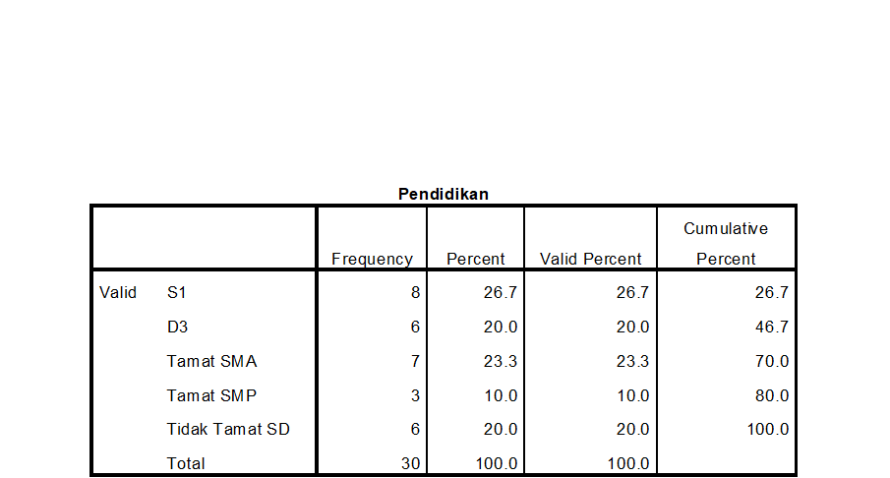

Table 4 Characteristic Data regarding
education

Table 5. Data Distribution of Knowledge Regarding Flood Disaster

Table.6. Conclusion on the level of knowledge of respondents about flood disaster

Table 7. Leadership Distribution Data at the sub-district level

Table 8 Behavioral Distribution Data

Table 9. Collinearity test results
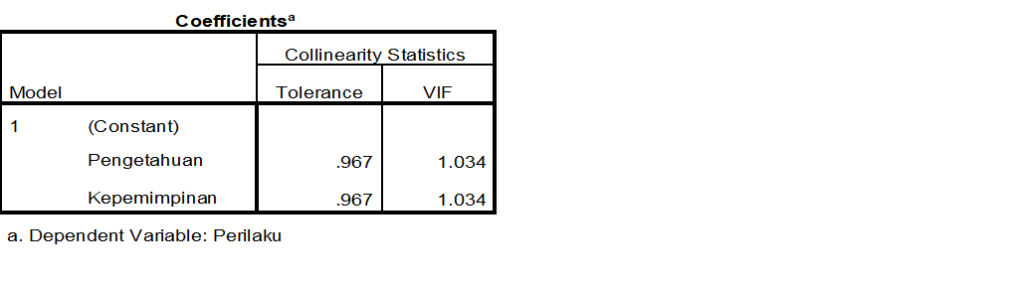

the value of Variance Inflation Factor (VIF) is 1.034, which is smaller than 10; 1.034 < 10. So it can be concluded that there is no multicollinearity problem between independent variables, so it is feasible to use to analyze the data results.

Table 10 Simultaneous Calculations

From the calculation results above, it can be seen that the influence of knowledge and leadership simultaneously on flood disaster preparedness behavior is 95.4%. While the remaining 0.046 or 4.6% are epsilon variables, namely variables that affect flood disaster preparedness behavior but were not examined in this study.

Table 11. Results of Simultaneous Path Analysis

Based on table 11. it can be seen that the value of F = 280.802 (sig = 0.000, p <0.05), it can be concluded that rejecting Ho means that the camat leadership and disaster knowledge together or simultaneously have a significant contribution to flood disaster preparedness behavior.
Table 12. Partial Pathway Analysis Results

Based on table 12, it means that the value of this study also shows that the Beta coefficient for disaster knowledge is 0.097 (sig = 0.028, p <0.05), then rejecting H0 means that disaster knowledge contributes individually and significantly to disaster preparedness behavior. In addition, this study also shows that the beta coefficient for leadership (camat) is 0.954 (sig = 0.000, p <0.05), then rejecting H0 means that leadership also contributes individually and significantly to disaster preparedness behavior.
A. Discussion

B.1. Respondent characteristic data

Data on the characteristics of respondents in this study were used to determine the diversity of respondents based on gender, age, education and occupation. According to Mubarak et al (2017), factors of education, age, interests, experience, surrounding culture, and information can also affect a person's low knowledge. This is expected to provide a fairly clear picture of the condition of the respondents and their relation to the problem and research objectives. In this study, data on educational characteristics which are dominated by formal education channels should be able to increase knowledge of disaster mitigation, but this is the opposite, so that efforts to increase public knowledge in flood prevention and management can be done through counseling or socialization of disaster mitigation. Furthermore, Dimyanti and Mudjiono (2009), Abraham (1991) Inkeles and Smith (1976) suggest that education is a strong and consistent predictor of one's attitudes, values, and behavior for the future.
So far, formal education has not provided complete knowledge of disaster mitigation. Therefore, in order to improve the quality of public knowledge in preventing and overcoming floods, it is necessary to improve through non-formal education for the people in the area. In such conditions, a leader's role is needed in managing the form of education that will be applied in the region, especially in the Abepura sub-district. Providing education in the era of the COVID-19 pandemic does not have to be face-to-face but can be done through various types of mass media. The existence of new information about a matter provides a new cognitive foundation for the formation of knowledge about it (Irfandi, 2009).
Characteristics data regarding work obtained in this study are expected to be able to provide an initial picture of the level of knowledge obtained by respondents, especially knowledge obtained from their association in the work environment. According to Wati (2009), work is an activity or activity of a person to earn income to meet the needs of his daily life.

B.2. Flood Disaster Knowledge

This study uses knowledge parameters, for the authors knowledge is an initial indicator to determine the level of flood preparedness behavior, knowledge related to disaster preparation in disaster-prone groups is the main focus (Priyanto, 2006). This is in accordance with the statement of Anderson and King (2005) that knowledge and preparedness in dealing with disasters are needed in community mitigation against disasters.
The results of this study indicate that the low knowledge of the people of Abepura District in terms of flood disaster preparedness, the low knowledge of flood preparedness is due to the lack of public interest in seeking information about disaster preparedness from several relevant agencies such as the Regional Disaster Management Agency (BPBD), the Technical Implementation Unit of the Ministry of Environment. and Forestry in Papua Province, apart from the lack of information about disaster management from the leadership of the regional apparatus, it also causes low knowledge of flood disaster preparedness.
Based on the results of the study, it shows that the low level of knowledge lies in several question parameters, namely not knowing about the causes of the flood disaster (60%), not knowing the actions taken during a flood disaster (53.34%), not knowing the natural phenomena that characterize the disaster (56.66 %) and do not know the classification of disasters (53.34%). This low level of knowledge about disaster preparedness is also in line with research by Nisa et al. (2019) which states that the knowledge of preparedness of health workers is still very low with a low percentage of 26% and very low 50%. The results of this study are in line with research from Harahap (2015) which explains that people in the Bukit Lawang plantation village are generally not ready to face floods. This is because they do not have preparedness or do not know the actions that must be taken before, during and after the flood.
The impact of low knowledge causes a lack of information so that people are not prepared when a disaster occurs. Research by Rogers (1974) reveals that knowledge or cognitive is a very important domain in shaping one's actions (overt behavior), where behavior based on knowledge will last longer than behavior that is not based on knowledge.

B.3. Leadership

Leadership in disaster management is absolutely necessary to support the effectiveness and achievement of the management of a disaster. Critical situations, full of uncertainty, system malfunctions and lack of resources, increasingly encourage the need for effective leadership.
This study shows that leadership at the sub-district level in Abepura sub-district is still low, it can be seen that several phases of disaster management leadership are still not optimally implemented, including the fact that disaster preparation planning has never been carried out (the percentage of answers has never been worth 50%), has never coordinated (the percentage of the answer is never worth 40%), and the response of the government (camat) is still lacking (the percentage of answers is never worth 30%).
This study uses questions about coordination and responses from leaders with the results that leaders at the Abepura sub-district level never coordinate and the government's response is very low. The two question items are to find out how far the main pillars of a leader have leadership in disaster management, according to Carter, 1992 the main pillars of leadership in disaster management include disaster situations inviting various parties to be able to become resources and play a broad role and in times of disaster leaders are needed. who have leadership traits and skills, not just formal leaders.
The ability to apply the concept of contextual leadership (Vail, 1989) along with changes in each stage of disaster management is the basis for implementing various variations of leadership styles. However, the objection to this idea is the limited ability of a person to master well each leadership style in a chaotic situation and, usually do not get the opportunity to prepare optimally.

B.4. Behavior
Based on the results of the study, it was found that the percentage value for the answer to never on the behavioral dimension of caring for nature is quite high, namely 40%, this indicates that respondents still behave or are not paying attention to natural sustainability and indicate that respondents do not have disaster preparedness, this can be seen in the answer value was never which showed a value of 33.33% on the preparedness dimension. The results of this study are in line with the results of research by Nur Alam, et al, 2020 which states that community behavior towards the attitude of preparedness to face landslides in Lonjoboko Village, Parangloe District can be categorized as poor. Behavior or attitude is a positive or negative response to something that will happen, meaning that the attitude has not yet arrived at an action (Notoadmojo, 2003).
Careful behavior towards environmental sustainability and disaster preparedness is one of the indicators for assessing preparedness behavior in this study. Attitude is a determinant of behavior because attitude is related to perception, personality and motivation. Attitude is not necessarily an action. To realize an attitude into an action, supporting factors are needed (Notoadmojo, 2010).
The low level of community preparedness behavior is due to the lack of knowledge and training obtained by the community. In this study, the lack of training and knowledge obtained by the community is suspected to be the cause of the less active role of a leader in disaster risk reduction efforts in providing disaster education about flood disasters and disasters affected by the flood. According to Finnis et al (2010), participation in disaster education can increase respondents' understanding of self-protection behavior during a disaster. According to Lawrence Green's theory in Notoatmodjo (2007), the factors that influence behavior are divided into 3 parts, namely predisposing factors (age, community knowledge level and community education level), enabling factors (facilities and facilities) and reinforcing factors (support from community leaders, behavior of health workers).

B.5. Relationship between knowledge and leadership on flood preparedness behavior

Based on the results of this study indicate that the relationship between knowledge and leadership simultaneously has a value of F = 280.802 (sig = 0.000, p <0.05), it can be concluded that the relationship between knowledge and leadership on flood preparedness behavior shows a strong relationship and has a positive pattern. This means that the more knowledge and leadership the better the preparedness behavior. This study also partially shows that disaster knowledge contributes individually and significantly to disaster preparedness behavior (ꞵ=0.097, sig=0.028, p<0.05) and leadership also contributes individually and significantly to disaster preparedness behavior (ꞵ=0.954 , sig=0.000, p<0.05). The results of this study are in line with the research conducted by Wahyuningsih (2013) in Joyotokan Village, Serengan District, Surakarta City about the influence of community knowledge and attitudes towards flood preparedness, the results of this study also show a significant relationship between attitudes towards flood disaster preparedness and -value = 0.012. As Twigg (2007) argues, if human knowledge of hazards, vulnerabilities, risks and risk reduction activities is sufficient, it will be able to create effective community action (either alone or in collaboration with other stakeholders) in dealing with disasters.
Based on the results of the study, it can be explained that in order to create a good flood preparedness behavior in the Abepura sub-district community in terms of flood management, knowledge is needed which is the main supporter of the community in acting and leaders who are able to carry out disaster management quickly, precisely and accurately. This shows that leaders must be able to handle disasters in abnormal situations and full of technical, psychological and ethical problems (Neira & Lic, 2004). In addition, whatever is done by humans is strongly influenced by the knowledge they have. Likewise in this case, the higher the nature of leadership possessed by a leader and the knowledge of the community, it will be able to give birth to a community with flood disaster preparedness behavior that is carried out at the stages of flood management, precisely before, during and after the flood.

I. CONCLUSION

Based on the data analysis and discussion above, in this study the following conclusions can be drawn:
1. The level of public knowledge is still low, because they do not know about the causes of the flood disaster (60%), do not know the actions taken during a flood disaster (53.34%), do not know the natural phenomena that characterize the disaster (56.66%) and do not know the grouping of disasters (53.34%).
2. The level of leadership is still low, it can be seen that disaster preparation planning has never been carried out (the percentage of answers has never been worth 50%), has never coordinated (the percentage of answers has never been worth 40%), and the government response (the sub-district head) is still lacking (the percentage of answers) never worth 30%).
3. The behavioral dimension is still relatively low, it can be shown from the results of the study in the form of the percentage value for the answer to never on the behavioral dimension of caring for nature conservation and not having disaster preparedness behavior which is quite high, namely 40% and 33.33%, respectively.
4. The relationship between knowledge and leadership simultaneously has a value of F=280.802 (sig=0.000, p<0.05). The partial relationship of disaster knowledge contributes individually and significantly to disaster preparedness behavior (ꞵ=0.097, sig=0.028, p<0.05) and leadership also contributes individually and significantly to disaster preparedness behavior (ꞵ=0.954, sig=0.000, p<0.05).

Based on the conclusions from the results of this study, the authors recommend that collective leadership is needed so that each individual will complement each other according to their strengths, so that it will increase the effectiveness of each phase of disaster management that has been planned.

REFERENCES

Abraham, M.F., 1991. Modernization in the Third World. A General Theory of Development, Tiara WacanaYogya, Yogyakarta.
Anderson and King. 2005. Mitigation of The Impact of Tropical Cyclones in Northern Australia through Community Capacity Enhancement. Volume 10, Issue 3, pp. 367-392.
Dimyanti and Mudjiono, 2009. Learning and Learning, Rineka Cipta, Jakarta.
Finnis, Kirsten K., David M, Johnston, Kevin R. Ronan et al. 2010. Hazards Perceptions, and preparedness of Taranaki Youth. Disaster Prevention and Management Journal. 19, (2).178.
please. E.M. (2015). The Effect of Knowledge and Attitudes on Community Preparedness in Facing Flood Disasters in the Bukit Lawang Plantation Village, Bahorok District in 2011. USU.
Irfandi. (2009). Pengetahuan dan Faktor-Faktor yang Mempengaruhi Pengetahuan. Diakses dari http://academica.edu.id [16 Maret 2020].
Mubarak, W. I. (2007). Promosi Kesehatan Sebuah Pengantar Proses Belajar Mengajar Dalam Pendidikan. Graha Ilmu: Yogyakarta
Nisa, W., Imran dan Agussabti. 2019. Knowledge about the Earthquake in Health in Pidie Jaya General Hospital With Meureudu Health Center. International Journal of Multicultural and Multireligious Understanding. Vol.6 No.3: 432-442.

Notoadmojo, S. 2003. Pendidikan dan perilaku Kesehatan. Jakarta: Rineka Cipta.
Notoatmodjo, S. 2007. Domain Perilaku Dalam Promosi Kesehatan Dan Ilmu Perilaku. Pt Rineka Cipta. Jakarta.

Notoadmojo, S. 2010. Pendidikan dan perilaku Kesehatan. Jakarta: Rineka Cipta.

Neira, J., Lic, L.B. 2004. The Word Accident: No Chance, No Error, No Destiny. Prehospital & Disaster Medicine; vol: 19, no. 3.
Nur alam. R.S, Nyompa, S, Leo Z N M. 2020. Studi Tingkat Pengetahuan Kebencanaan Terhadap Sikap Kesiapsiagaan Masyarakat Dalam Menghadapi Bencana Tanah Longsor Di Kecamatan Parangloe Kabupaten Gowa Tahun 2019. Jurnal Environmental Science. Volume 2 Nomor 2 April 2020
Priyanto, Agus (2006). Promosi Kesehatan Pada Situasi Emergensi. Edisi 2. Jakarta.

Vail, P. B. 1989. Managing as a Performing Art. Jossey-Bass, San Francisco.
Wati, R. (2009). Pengaruh Penyuluhan Terhadap Peningkatan Pengetahuan. Diakses dari http://enprints.uns.ac.id [16 Maret 2020].
Wahyuningsih. T. (2013). Pengaruh pengetahuan dan Sikap Masyarakat Terhadap Kesiapsiagaan Menghadapi Bencana Banjir Di Kelurahan Joyotokan Kecamatan Seragen Kota Surakarta. Skripsi. UMS

